**SUPPLEMENTARY MATERIAL: RESULTS FROM COMBINED INTERVENTION ANALYSIS**

Table 1. Combined intervention analyses model comparison statistics.

|  |  |  |  |  |
| --- | --- | --- | --- | --- |
| Model Comparison Statistics | Null Model | MVIC Model | TT Model | TT/MVIC Model |
| Δ AICc | - | + 32.94 | - 6.89 | - 15.62 |
| LRT vs Null | - | 0.984 (18) | <0.001*** (18) | <0.001*** (18) |
| Marginal R2 | 0.107 | 0.112 | 0.279 | 0.335 |
| Δ Marginal R2 (%) | - | + 0.5% | + 17.2% | + 22.8% |
| Conditional R2 | 0.949 | 0.95 | 0.944 | 0.941 |

* = p < 0.05, ** = p < 0.01, *** = p < 0.001; for Likelihood ratio test compared to Null model (LRT vs Null), values represent p values and (degrees of freedom); ΔAICc = Change in Akaike information criterion from Null model; Marginal R2 = Explained variability of TT responses from the fixed effects alone of the models; ΔMarginal R2 (%) = change in Marginal R2 (expressed as a percentage)from Null model; Conditional R2 = Explained variability of TT responses by both the fixed and random effects of the models;

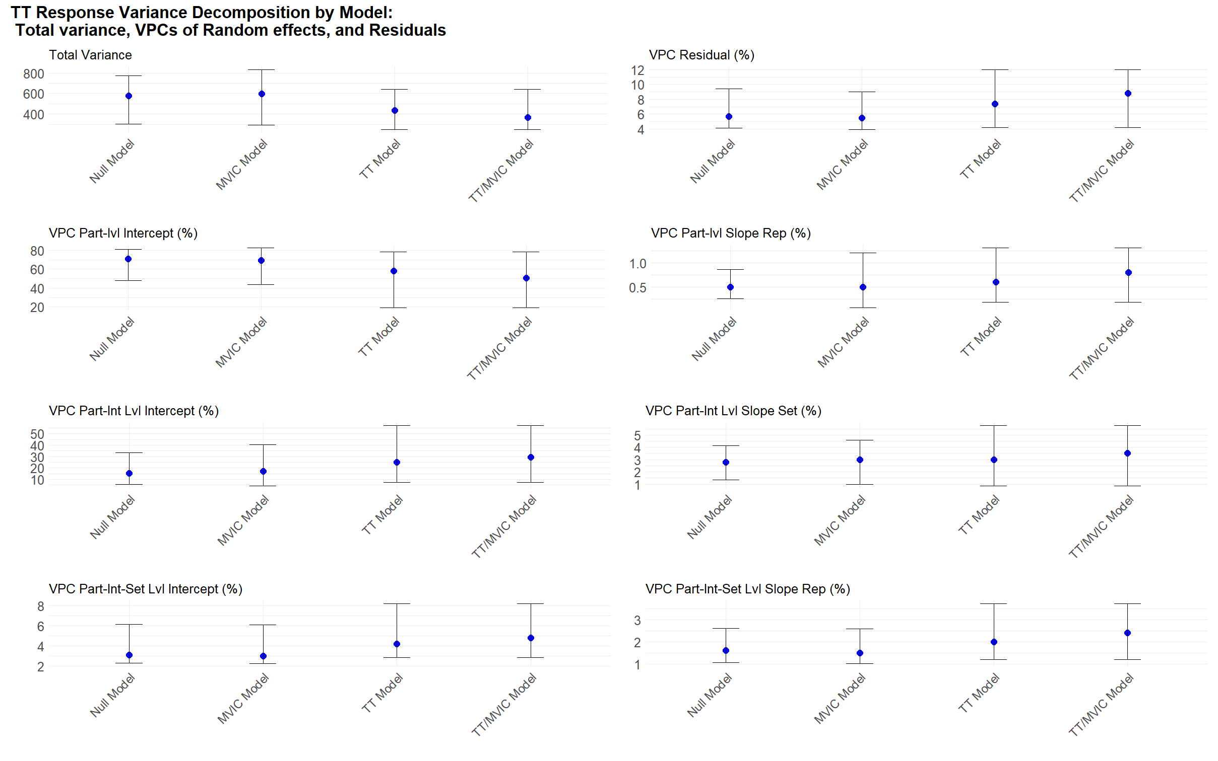

Figure . Combined intervention models Variance Components Decomposition. Variance Decomposition of Null, baseline MVIC, TT and TT/MVIC models of TT response. Total Variance = Variance captured by all random effects and residuals; VPCs of Part-lvl = Inter-Individual random effects across the entire study’s protocol; VPCs of Part-Int lvl = Intra-individual random effects for interventions within participants; VPCs of Part-Set lvl = Intra-individual intra-intervention random effects for sets within interventions; Blue dots = model estimated VPCs; Spread = Bootstrap 95% confidence intervals of VPCs; Intercepts = individual mean responses (Part-lvl), within interventions (Part-Int Lvl) and within sets within interventions (Part-Int-Set lvl).

Table . Variance decomposition Combined intervention analyses

|  |  |  |  |  |
| --- | --- | --- | --- | --- |
| Variance Components (random effects) | Null Model | MVIC Model | TT Model | TT/MVIC Model |
| Total Variance | 578.237 (303.38:775.16) | 596.281 (295.52:831.71) | 437.196 (246.57:639.93) | 368.019 (216.83:520.2) |
| VPC Part-lvl Intercept | 0.71 (0.48:0.81) | 0.695 (0.43:0.83) | 0.579 (0.19:0.78) | 0.505 (0.14:0.73) |
| VPC Part-lvl Slope Rep | 0.005 (0:0.01) | 0.005 (0:0.01) | 0.006 (0:0.01) | 0.008 (0:0.01) |
| VPC Residual | 0.057 (0.04:0.09) | 0.055 (0.04:0.09) | 0.074 (0.04:0.12) | 0.088 (0.05:0.13) |
| VPC Part-Int-Set Lvl Intercept | 0.031 (0.02:0.06) | 0.03 (0.02:0.06) | 0.042 (0.03:0.08) | 0.048 (0.03:0.1) |
| VPC Part-Int-Set Lvl Slope Rep | 0.016 (0.01:0.03) | 0.015 (0.01:0.03) | 0.02 (0.01:0.04) | 0.024 (0.01:0.04) |
| VPC Part-Int-Set Lvl Slope Quad.Rep | 0.001 | 0.001 | 0.001 | 0.001 |
| VPC Part-Int Lvl Intercept | 0.152 (0.05:0.33) | 0.168 (0.04:0.4) | 0.248 (0.07:0.57) | 0.292 (0.07:0.61) |
| VPC Part-Int Lvl Slope Set | 0.028 (0.01:0.04) | 0.03 (0.01:0.05) | 0.03 (0.01:0.06) | 0.035 (0.02:0.06) |

The table presents estimates of total variance by model and VPCs of each random effect along with estimated bootstrapped 95% confidence intervals (Lower 95%CI: Upper 95%CI) of these variance components. Abbreviations: MVIC = Baseline maximum voluntary contraction torque model; TT = Baseline twitch torque model; TT/MVIC = Baseline TT/MVIC ratio model; VPC = Variance partition coefficients; Part-lvl = Random effect at the inter-participant level; Part-Int lvl = Random effect at the intra-participant-inter-intervention level; Part-Int-Set lvl = Random effect at the intra-participant intra-intervention inter-set level; Random Intercepts = refer to mean responses across sets and repetitions at each respective level.

Table . Correlations between Variance components

|  |  |  |  |  |
| --- | --- | --- | --- | --- |
| Correlation between Variance Components | Null Model | MVIC Model | TT Model | TT/MVIC Model |
| Corr. Part Lvl Interc.& Sl. Rep | -0.323 | -0.284 | 0.005 | -0.004 |
| Corr. Part-Int-Set Lvl Interc.& Sl. Rep | -0.063 | -0.059 | -0.085 | -0.145 |
| Corr. Part-Int Lvl Interc.& Sl. Set | 0.069 | 0.044 | -0.028 | 0.116 |

The table presents estimates of the correlations between inter-individual mean response differences (Part-lvl) and inter-individual differences in effects of repetitions across the entire study. Part-Int lvl Intercept & Slope Set, refers to estimates of the correlations between intra-individual inter-intervention mean response differences and intra-individual inter-intervention differences in effects of sets. Part-Int-Set lvl Intercept & Slope Repetition, refers to estimates of the correlations between intra-individual intra-intervention inter-set mean response differences and intra-individual intra-intervention differences in effects of repetitions.

Table . Combined intervention Fixed effects model parameter estimates

|  |  |  |  |  |
| --- | --- | --- | --- | --- |
| Variable | Null Model | MVIC Model | TT Model | TT/MVIC Model |
| Fixed effects |  |  |  |  |
| (Intercept) | 82.87*** se: 5.846 pval: <0.001 (73.81:92.13) | 82.875*** se: 5.857 pval: <0.001 (73.93:93.31) | 82.865*** se: 4.849 pval: <0.001 (73.89:91.76) | 82.783*** se: 4.431 pval: <0.001 (74.51:91.12) |
| *Baseline Parameter Fixed Effects Moderated by intervention (direct interaction tests of differences between 3s and 6s intervention)* | | | | |
| Rep_c:Set_c:intervention6s:baseline | - | 0.009 se: 0.02 pval: 0.644 (-0.05:0.07) | -0.305 se: 0.179 pval: 0.089 (-0.6:0.2) | -0.913 se: 0.485 pval: 0.061 (-1.79:0.52) |
| Rep_c:intervention6s:baseline | - | 0.027 se: 0.023 pval: 0.243 (-0.04:0.12) | 0.264 se: 0.202 pval: 0.191 (-0.47:0.59) | 0.99 se: 0.557 pval: 0.076 (-0.82:2.37) |
| Set_c:intervention6s:baseline | - | 0.001 se: 0.042 pval: 0.972 (-0.08:0.09) | -0.551 se: 0.344 pval: 0.119 (-1.02:0.25) | -0.551 se: 0.925 pval: 0.556 (-1.64:1.25) |
| Set_c:intervention6s:baseline:I(Rep_c^2) | - | 0.002 se: 0.005 pval: 0.716 (0:0.01) | 0.042 se: 0.042 pval: 0.313 (-0.01:0.14) | 0.021 se: 0.114 pval: 0.854 (-0.15:0.22) |
| Set_c:intervention6s:baseline:I(Rep_c^3) | - | -0.001 se: 0.003 pval: 0.709 (-0.01:0.01) | 0.039 se: 0.026 pval: 0.138 (-0.04:0.09) | 0.09 se: 0.072 pval: 0.212 (-0.11:0.23) |
| intervention6s:baseline | - | -0.063 se: 0.1 pval: 0.536 (-0.36:0.11) | -0.016 se: 0.899 pval: 0.986 (-2.89:1.95) | -2.084 se: 2.476 pval: 0.413 (-9.35:2.14) |
| intervention6s:baseline:I(Rep_c^2) | - | 0.003 se: 0.006 pval: 0.598 (-0.01:0.02) | 0.001 se: 0.047 pval: 0.985 (-0.18:0.11) | 0.182 se: 0.127 pval: 0.156 (-0.2:0.41) |
| intervention6s:baseline:I(Rep_c^3) | - | -0.003 se: 0.003 pval: 0.347 (-0.01:0) | -0.018 se: 0.029 pval: 0.537 (-0.04:0.04) | -0.06 se: 0.08 pval: 0.454 (-0.14:0.12) |
| intervention6s:baseline:I(Set_c^2) | - | 0.034 se: 0.023 pval: 0.142 (0:0.07) | -0.156 se: 0.206 pval: 0.452 (-0.31:0.51) | -0.922 se: 0.551 pval: 0.100 (-1.26:0.26) |
| *Baseline Parameter Fixed effects for intervention 3s* | Null Model | MVIC Model | TT Model | TT/MVIC Model |
| Rep_c:Set_c:baseline | - | -0.003 se: 0.014 pval: 0.835 (-0.02:0.03) | 0.196 se: 0.139 pval: 0.160 (-0.1:0.34) | 0.373 se: 0.321 pval: 0.247 (-0.25:0.94) |
| Rep_c:baseline | - | -0.01 se: 0.017 pval: 0.560 (-0.03:0.04) | 0.118 se: 0.181 pval: 0.516 (-0.15:0.32) | 0.353 se: 0.41 pval: 0.391 (-0.44:0.97) |
| Set_c:baseline | - | -0.005 se: 0.029 pval: 0.864 (-0.05:0.09) | 0.774**c se: 0.268 pval: 0.007 (-0.08:1.1) | 1.672* se: 0.613 pval: 0.010 (0.04:2.66) |
| Set_c:baseline:I(Rep_c^2) | - | -0.001 se: 0.003 pval: 0.764 (-0.01:0) | -0.062 se: 0.033 pval: 0.059 (-0.11:0) | -0.103 se: 0.075 pval: 0.173 (-0.21:0.06) |
| Set_c:baseline:I(Rep_c^3) | - | -0.001 se: 0.002 pval: 0.639 (-0.01:0) | -0.038 se: 0.021 pval: 0.062 (-0.09:-0.01) | -0.058 se: 0.047 pval: 0.225 (-0.16:0.04) |
| baseline | - | 0.062 se: 0.093 pval: 0.508 (-0.13:0.37) | -2.305*c se: 1.107 pval: 0.047 (-4.92:1.59) | -5.956** se: 2.147 pval: 0.010 (-10.2:-0.43) |
| baseline:I(Rep_c^2) | - | 0 se: 0.004 pval: 0.930 (-0.01:0.02) | 0.106**c se: 0.036 pval: 0.004 (-0.04:0.22) | 0.213*c se: 0.084 pval: 0.013 (-0.05:0.47) |
| baseline:I(Rep_c^3) | - | 0.003 se: 0.002 pval: 0.262 (0:0.01) | -0.013 se: 0.023 pval: 0.581 (-0.05:0) | -0.061 se: 0.053 pval: 0.250 (-0.16:0) |
| baseline:I(Set_c^2) | - | -0.016 se: 0.016 pval: 0.306 (-0.04:0.01) | 0.134 se: 0.161 pval: 0.408 (-0.38:0.29) | 0.501 se: 0.365 pval: 0.176 (-0.05:0.83) |
| *Intervention Parameter Fixed Effects* | Null Model | MVIC Model | TT Model | TT/MVIC Model |
| I(Rep_c^2) | -1.253*** se: 0.161 pval: <0.001 (-1.76:-0.79) | -1.253*** se: 0.16 pval: <0.001 (-1.75:-0.7) | -1.253*** se: 0.148 pval: <0.001 (-1.7:-0.82) | -1.253*** se: 0.148 pval: <0.001 (-1.74:-0.8) |
| I(Rep_c^3) | 0.365*** se: 0.095 pval: <0.001 (0.26:0.48) | 0.365*** se: 0.095 pval: <0.001 (0.25:0.46) | 0.365*** se: 0.093 pval: <0.001 (0.23:0.48) | 0.365*** se: 0.093 pval: <0.001 (0.24:0.46) |
| I(Set_c^2) | -2.374*** se: 0.672 pval: <0.001 (-3.59:-1.53) | -2.379*** se: 0.659 pval: <0.001 (-3.62:-1.43) | -2.371*** se: 0.655 pval: <0.001 (-3.76:-1.5) | -2.305*** se: 0.642 pval: <0.001 (-3.61:-1.43) |
| Rep_c | 1.411 se: 0.774 pval: 0.073 (0.47:2.4) | 1.411 se: 0.767 pval: 0.070 (0.5:2.48) | 1.411 se: 0.746 pval: 0.063 (0.46:2.48) | 1.411 se: 0.757 pval: 0.067 (0.53:2.52) |
| Rep_c:Set_c | -0.757 se: 0.578 pval: 0.191 (-1.56:0.05) | -0.757 se: 0.575 pval: 0.189 (-1.52:0.27) | -0.757 se: 0.567 pval: 0.183 (-1.62:-0.05) | -0.757 se: 0.565 pval: 0.181 (-1.55:-0.01) |
| Rep_c:Set_c:intervention6s | -0.819 se: 0.817 pval: 0.317 (-2.54:0.75) | -0.819 se: 0.812 pval: 0.314 (-2.82:0.66) | -0.819 se: 0.802 pval: 0.308 (-2.41:0.73) | -0.819 se: 0.799 pval: 0.306 (-2.58:0.56) |
| Rep_c:intervention6s | -4.68*** se: 0.913 pval: <0.001 (-6.46:-2.75) | -4.68*** se: 0.908 pval: <0.001 (-7.14:-2.75) | -4.68*** se: 0.897 pval: <0.001 (-6.55:-2.78) | -4.68*** se: 0.893 pval: <0.001 (-6.71:-2.78) |
| Set_c | -0.396 se: 1.218 pval: 0.747 (-2.51:1.59) | -0.396 se: 1.216 pval: 0.747 (-2.53:2.02) | -0.396 se: 1.092 pval: 0.719 (-2.45:1.22) | -0.396 se: 1.078 pval: 0.715 (-2.47:1.4) |
| Set_c:I(Rep_c^2) | 0.28 se: 0.144 pval: 0.054 (0:0.55) | 0.28 se: 0.143 pval: 0.053 (-0.05:0.55) | 0.28*c se: 0.133 pval: 0.037 (0:0.54) | 0.28*c se: 0.133 pval: 0.036 (-0.01:0.56) |
| Set_c:I(Rep_c^3) | -0.004 se: 0.085 pval: 0.967 (-0.16:0.16) | -0.004 se: 0.085 pval: 0.967 (-0.19:0.15) | -0.004 se: 0.084 pval: 0.966 (-0.15:0.13) | -0.004 se: 0.083 pval: 0.966 (-0.15:0.16) |
| Set_c:intervention6s | -7.692*** se: 1.722 pval: <0.001 (-9.83:-5.48) | -7.692*** se: 1.72 pval: <0.001 (-10.62:-5.53) | -7.692*** se: 1.544 pval: <0.001 (-9.81:-5.18) | -7.692*** se: 1.524 pval: <0.001 (-9.98:-5.18) |
| Set_c:intervention6s:I(Rep_c^2) | -0.061 se: 0.204 pval: 0.766 (-0.38:0.24) | -0.061 se: 0.203 pval: 0.765 (-0.37:0.29) | -0.061 se: 0.188 pval: 0.747 (-0.39:0.31) | -0.061 se: 0.188 pval: 0.747 (-0.4:0.32) |
| Set_c:intervention6s:I(Rep_c^3) | 0.156 se: 0.12 pval: 0.195 (-0.11:0.45) | 0.156 se: 0.12 pval: 0.194 (-0.11:0.49) | 0.156 se: 0.118 pval: 0.189 (-0.1:0.43) | 0.156 se: 0.118 pval: 0.188 (-0.1:0.47) |
| intervention6s | -4.27 se: 3.755 pval: 0.271 (-10.29:2.61) | -4.264 se: 3.705 pval: 0.266 (-11.77:3.76) | -4.204 se: 3.898 pval: 0.297 (-11.02:3.79) | -4.254 se: 3.827 pval: 0.285 (-11.46:3.94) |
| intervention6s:I(Rep_c^2) | 0.252 se: 0.228 pval: 0.270 (-0.22:0.75) | 0.252 se: 0.226 pval: 0.267 (-0.32:0.74) | 0.252 se: 0.21 pval: 0.231 (-0.24:0.78) | 0.252 se: 0.21 pval: 0.231 (-0.26:0.76) |
| intervention6s:I(Rep_c^3) | 0.013 se: 0.134 pval: 0.922 (-0.15:0.17) | 0.013 se: 0.134 pval: 0.922 (-0.12:0.2) | 0.013 se: 0.132 pval: 0.921 (-0.14:0.18) | 0.013 se: 0.132 pval: 0.921 (-0.14:0.18) |
| intervention6s:I(Set_c^2) | 2.339* se: 0.951 pval: 0.017 (0.65:3.37) | 2.335* se: 0.932 pval: 0.015 (0.73:3.21) | 2.286* se: 0.926 pval: 0.017 (0.59:3.57) | 2.327* se: 0.908 pval: 0.013 (0.55:3.26) |

*\* = p < 0.05, ** = p < 0.01, *** = p < 0.001; c = significance corrected by confidence intervals including zero.   
Model parameter estimates, standard errors (se), p values (pval) are reported along with their bootstrapped 95% confidence intervals (Lower 95%CI: Upper 95%CI). Abbreviations: MVIC = Baseline maximum voluntary contraction torque model; TT = Baseline twitch torque model; TT/MVIC = Baseline TT/MVIC ratio model; Rep_c = Repetition intervention parameter, mean centered; Set_c = Set intervention parameter, mean centered; ^2 = a specified quadratic effect; ^3 = a specified cubic effect; Interactions are specified with “:”.*